Acrobat Sign through Adobe
- Log into adobe creative cloud online
  - https://www.adobe.com/home
- Go to Apps
  - Select Acrobat for the web
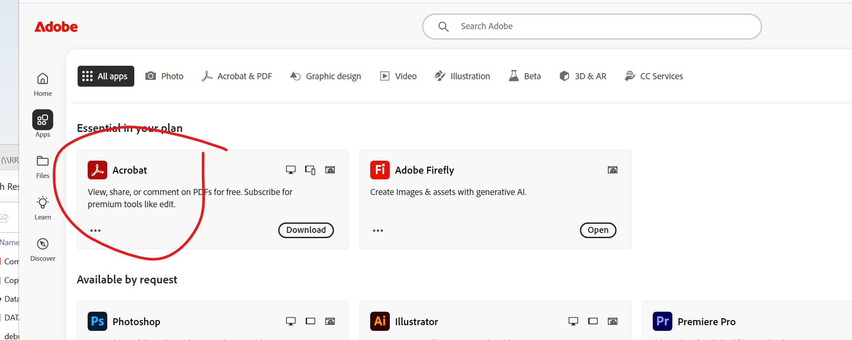

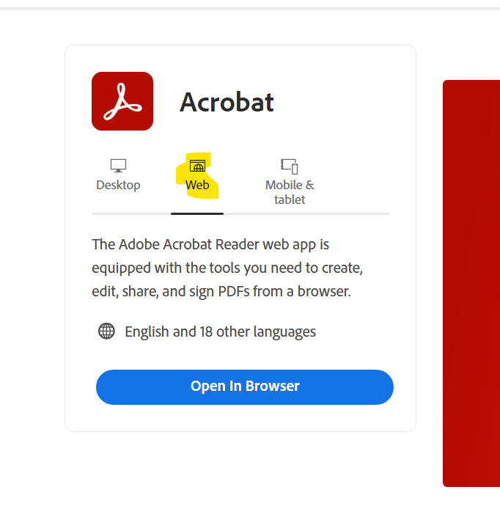
- Click open in browser
- Select request e-signature

- Drag & drop file(s) to send
  - File can not exceed 10 mb size
  - Document can not have more than 100 pages
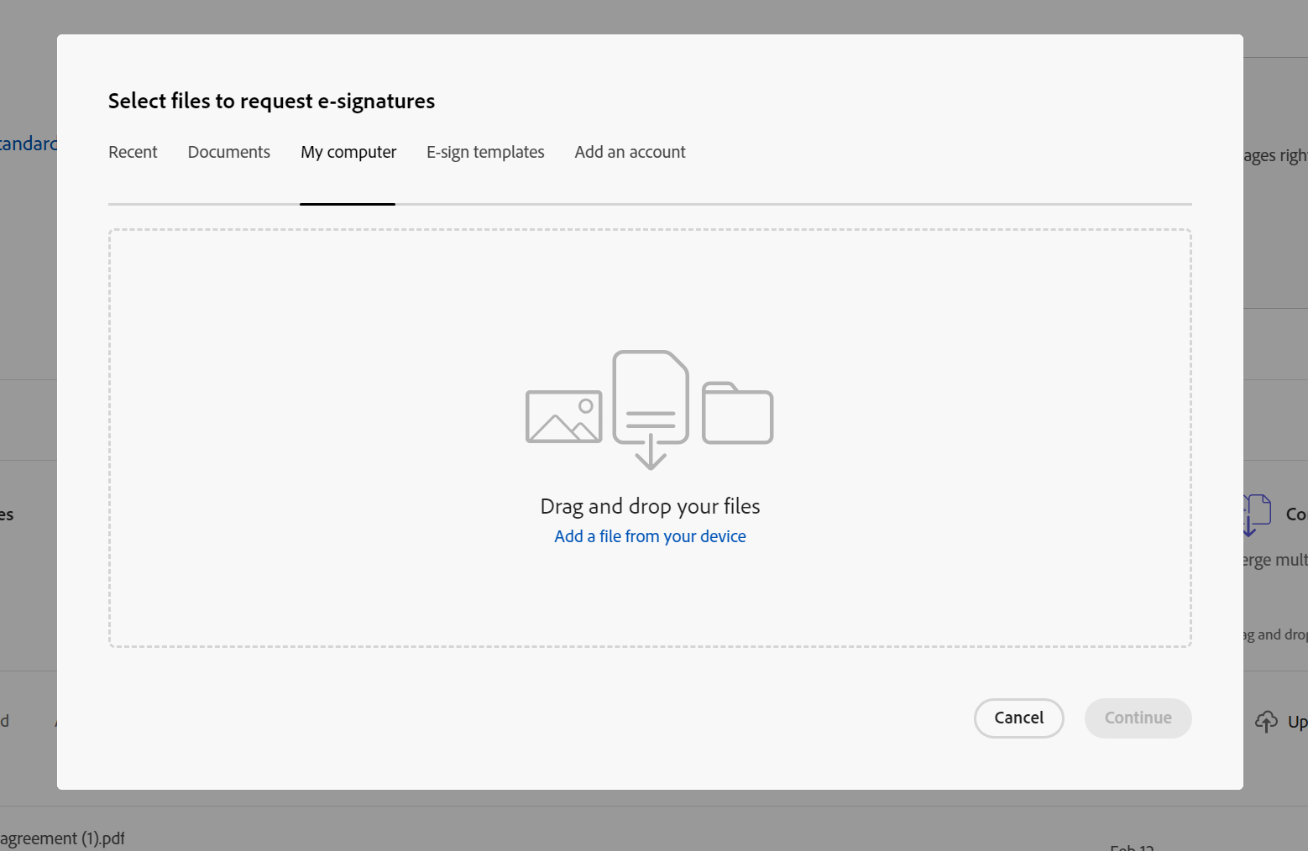

- Once file(s) is/are uploaded, click continue
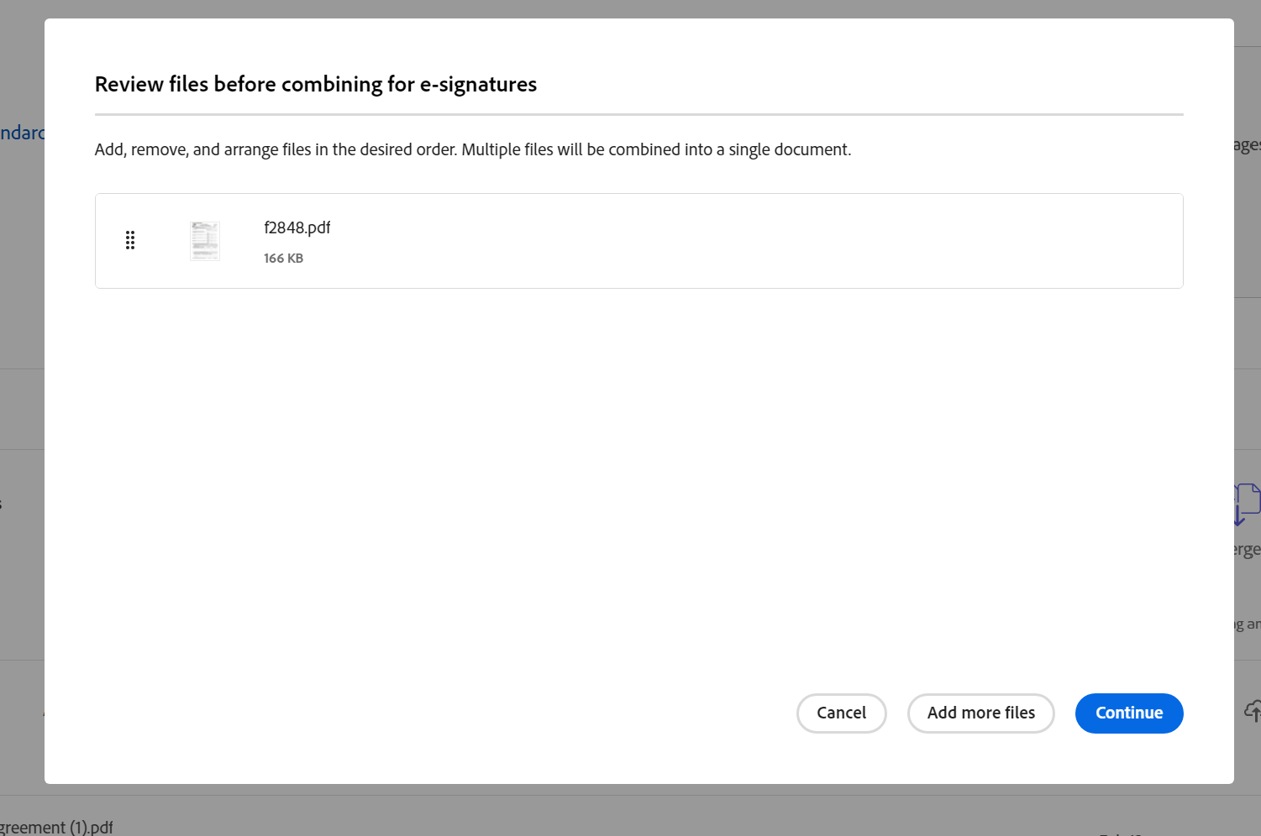
- Add fields by dragging from left panel to field location on document
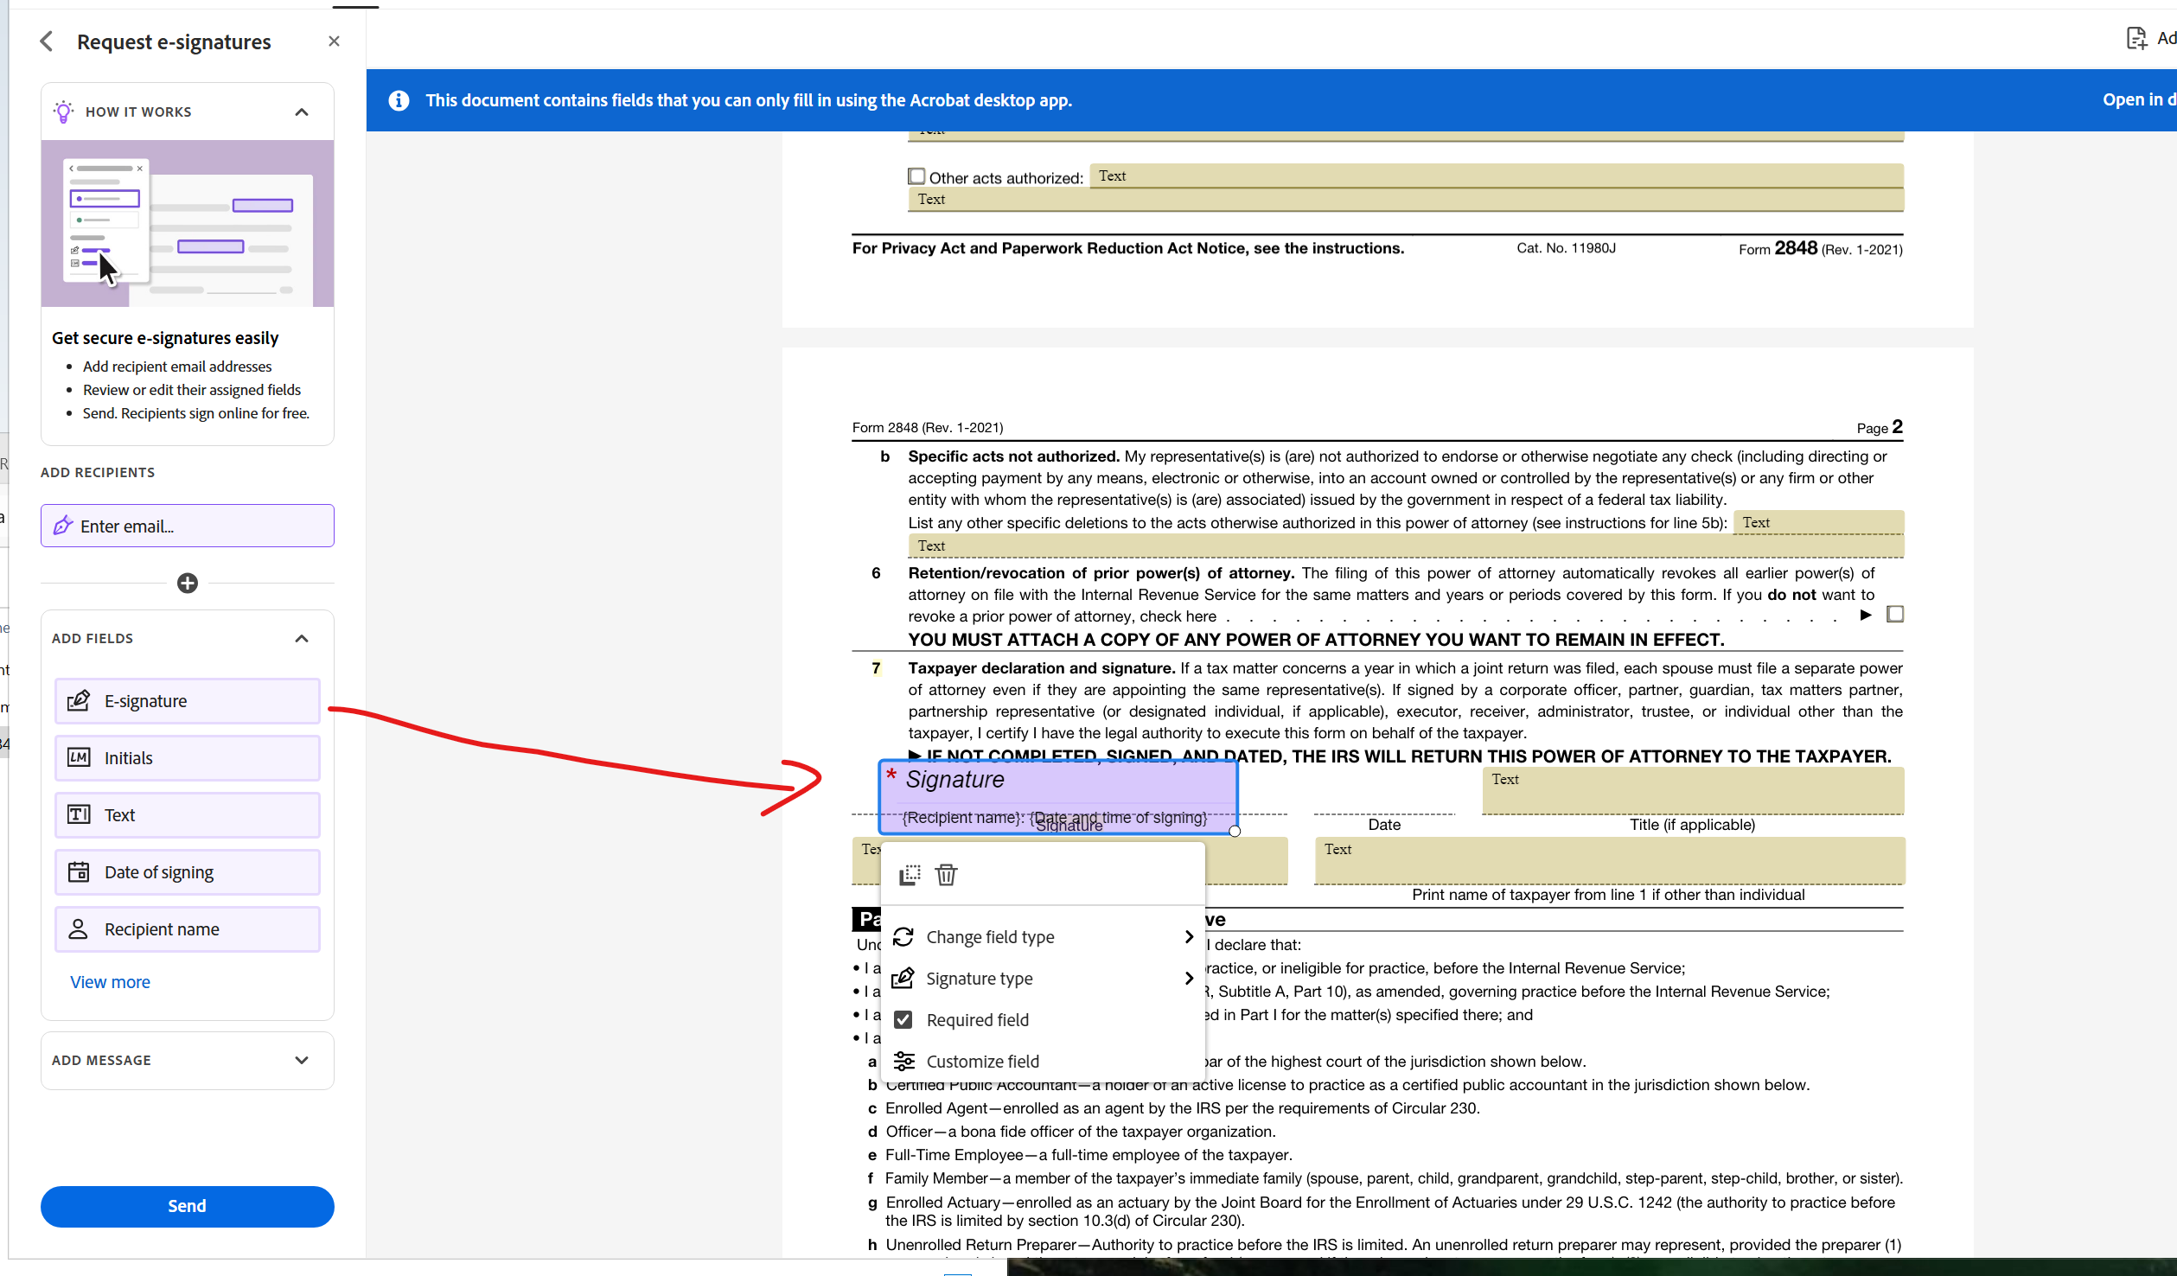
- You can edit the filed by clicking on it.
  - Select if the field is required or not. If required, the client can not complete until that field is addressed.
- Add recipient and message on left toolbar.
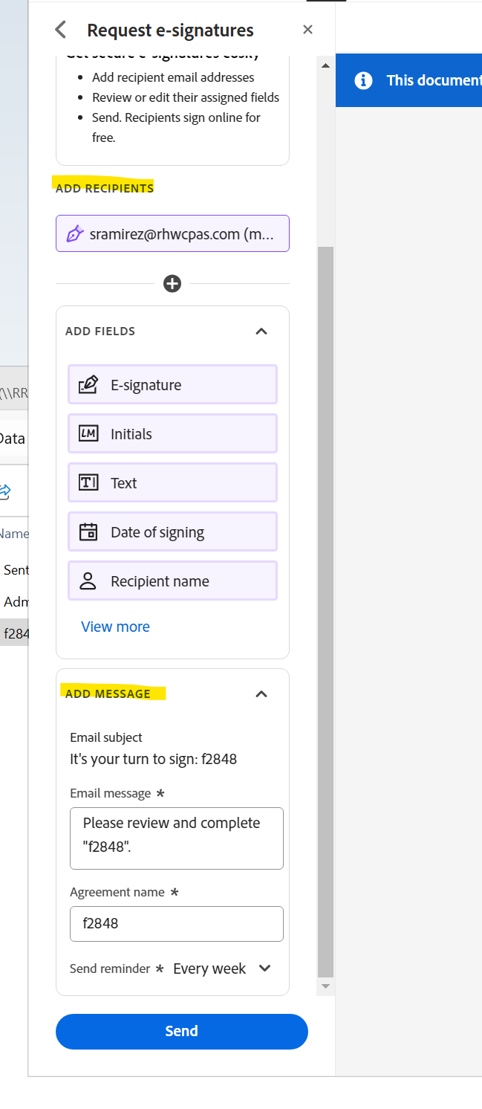
  - You can add up to 10 people on one transaction (signature request).
- Once you are done, click Send button on bottom left.

*There is no way to send an encrypted adobe signature request, so if the file has sensitive information it must be sent via safesend signatures.*

You CAN upload a fillable pdf and create templates similar to DocuSign.
Anything that is sent via adobe is linked only to the account through which it’s sent, so it’s best to use the RHW login that way all admins have access to sent transactions.

RHW login
rhw@rhwcpas.com
LamaDrama218!1

